https://premium.wpmudev.org/blog/a-wordpress-tutorial-for-beginners-create-your-first-site-in-10-steps/:
A WordPress Tutorial for Beginners: Create Your First Site in 10 Steps
he first time you step foot inside the WordPress dashboard, you can’t help but marvel at how simple it all appears to be. A management sidebar on the left. A clean interface to work within in the center. Notifications at the top.
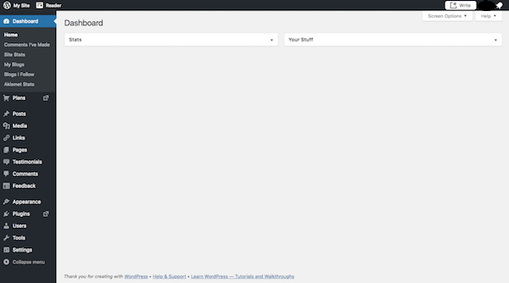
But once you start digging deeper into WordPress, you may feel overwhelmed as you dig deeper into the layers of functionality within the content management system.
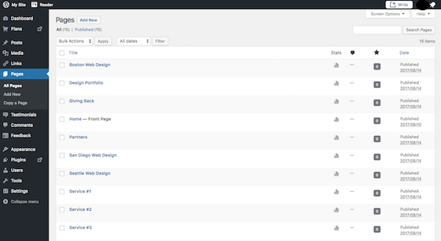
So, let’s talk practical steps here.
What do you need to do to get started in WordPress and end up with a website that’s ready to impress visitors straight out the gate? And how can you do this in the most efficient manner as possible, even without prior experience in WordPress? The following WordPress tutorial will walk you through all the necessary steps in setting up your first WordPress site.

Contents
WordPress Tutorial for Beginners: Step-by-Step 4
Step 1: Choose a Domain 4
Step 2: Purchase Web Hosting and Domain 4
Step 3: Install WordPress 6
Step 4: Find a WordPress Theme 8
Step 5: Install Your WordPress Theme 9
Step 6: Configure Your WordPress Theme 11
Step 7: Publish Your First Pages 13
Step 8: Create a Menu 14
Step 9: Configure Your WordPress Settings 18
Step 10: Install Essential WordPress Plugins 23
Wrapping Up 26
The Ultimate WordPress Backend Customization Tutorial 27
1. Install a Branding Plugin 30
2. Customize the Login Page 31
3. Adjust Login Security Settings 33
4. Change the Toolbar Message 34
5. Revamp the Admin Toolbar Menu 34
6. Revamp the Admin Menu Sidebar 35
7. Hide Plugins 37
8. Customize the Colors of the Dashboard 37
9. Remove Dashboard Widgets 38
10. Add Dashboard Widgets 39
11. Create Help Resources 40
12. Add Tips Around WordPress 41
13. Restrict Access Based on Role 42
Wrapping Up 43

WordPress Tutorial for Beginners: Step-by-Step
Before you even step inside WordPress, you need to do some work to find a home for it. So, let’s start with the steps you need to tackle outside of WordPress, and then move inside the platform once we have you all set up.

Step 1: Choose a Domain
This is a web domain:
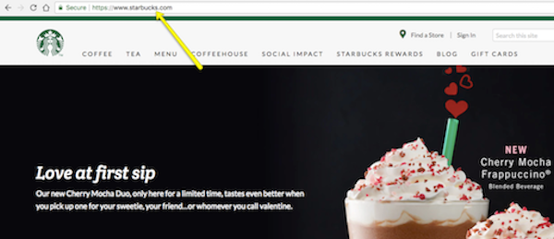
It will serve as the URL inside your visitors’ address bar when they visit your WordPress site. Make sure it is:
- Relatively short
- Easy to remember and type out
- Matches your brand name or is directly related to it
Unless you have already purchased a domain for your website, it’s best to do so when you purchase your web hosting plan (especially since some plans will include a free domain).
So long as no one has claimed the name before, you’ll have your choice of top-level domain (TLD) as well. A TLD is the suffix you attach to the URL like .com, .edu, .biz, etc. There are even ones available for specific industries as well as based on your geographic location (like .uk and .eu). Google has a pretty good roundup on the various TLDs you can choose from.

Step 2: Purchase Web Hosting and Domain
Web hosting does exactly what it says: it “hosts” websites. In other words, web hosting companies own and manage giant web servers located in data centers around the country (and, sometimes, the world).
It’s on these web servers where websites like yours sit, so you don’t have to buy or manage any of the server technology yourself. You pay these companies what amounts to a monthly or annual rent for space and bandwidth on the server. Then, you can focus on building your website in WordPress.
In terms of choosing a hosting plan, you should think about what you actually want to do with your website.
- Creating a small internal and private company site? WordPress.com hosting should be fine.
- Running a blog? Shared hosting is a good place to start.
- Launching a new business venture and want to collect leads and/or payments? Cloud hosting is a smart choice.
- If you anticipate heavy traffic for your established business or e-commerce company to start, then go with VPS.
Once you start receiving heavy traffic and are doing lots of business through your site, you may want to consider moving to managed WordPress hosting. To start, though, go with one of the options above.
While there isn’t one clear front-runner when it comes to hosting providers, WordPress does give some solid recommendations on companies that not only work well with WordPress websites, but that offer affordable hosting plans. I’d suggest you start with one of these if this is your first website.
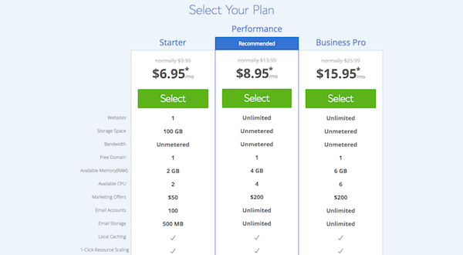
Signing up for web hosting is easy–it’s like purchasing any other software or service. Just make sure to buy your domain name at the same time. And, if it’s available, get yourself an SSL certificate to boost security while you’re at it.
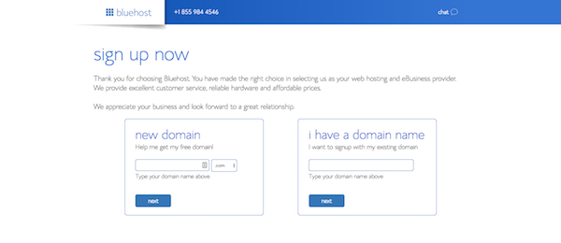
Enter your account and payment information, verify the details of your web hosting plan and domain purchase, and create your new account.

Step 3: Install WordPress
There are a number of ways in which you can install WordPress. However, most web hosting providers will provide you with an easy-to-use one-click installation process that simplifies the whole process.
Using BlueHost as an example, here is what you need to do:
First, log into your new web hosting account:
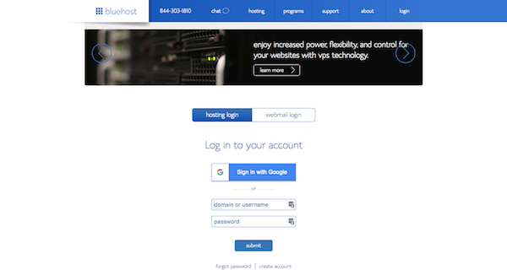
You’ll then arrive at your web hosting dashboard:
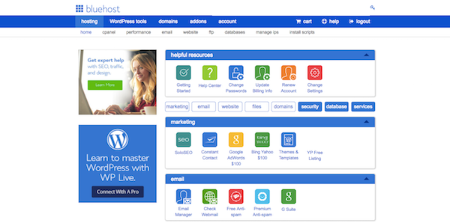
Unless you’re a seasoned web developer who knows his or her way around a control panel and is comfortable configuring PHP and email settings, you can ignore most of what’s in here for now. What you’ll want to look for instead is a button that says “Install WordPress”:
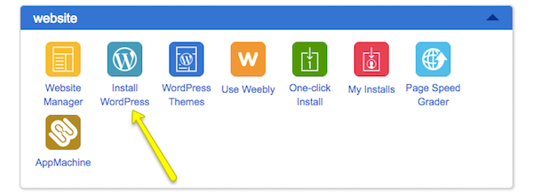
They may try to offer upgraded installation services, but there’s no need for that. Simply follow the instructions for installing WordPress.
Once you have completed the installation and created your WordPress login credentials, it’s time to step inside. Here is what your admin login screen will look like:
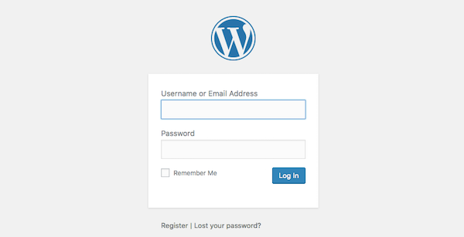
Unless you change your login domain (which you eventually should for security reasons), your admin login will be located at www.yourdomainname.com/wp-login.php.

Step 4: Find a WordPress Theme
You may be tempted to start combing through the various settings and pages in the WordPress menu, but hold on that for now. The first thing you need to do here is to find a theme for your site.
A WordPress theme is a pre-designed and pre-coded interface template for WordPress. Basically, it saves you the trouble (and money) of having to design your own website from-scratch or to pay someone else to do it for you.
When you log into WordPress for the first time, WordPress will automatically assign their latest theme to your site.
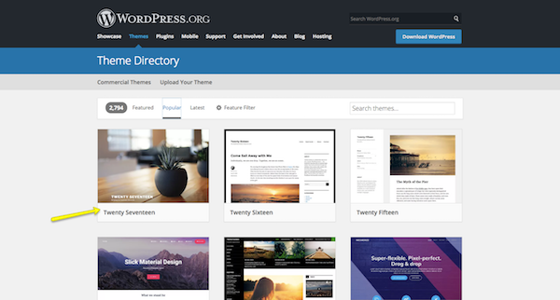
There’s absolutely nothing wrong with using this theme, especially since it’s built by WordPress developers. However, it’s a very basic theme and one that’s not likely going to be useful if you want to do anything more than blog or create a simple site for a local business.
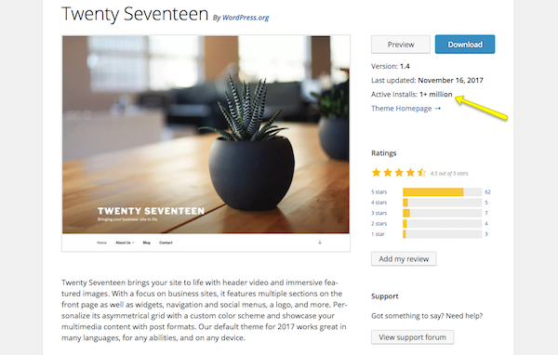
If you want to use a WordPress theme that works better for your niche, don’t be afraid to look around and to find the best and most trustworthy WordPress theme for your purposes.
Keep in mind that every theme requires some configuration. Also, not every theme works the same way. Some utilize a basic text editor (which looks similar to the blank page in Microsoft Word) while others use a page builder or visual editor. So, switching from one theme to another will force you to do a little rework if or when you make a switch. If you want to spare yourself the possible hassle, then don’t move on to the next steps until you’ve found the perfect WordPress theme for your site.

Step 5: Install Your WordPress Theme
When you find that perfect WordPress theme, it’s time install it in WordPress.
Free WordPress Themes
If you’re using a free theme from the WordPress repository, here is what you need to do:
Inside WordPress, go to the Appearance tab and click on “Themes”.
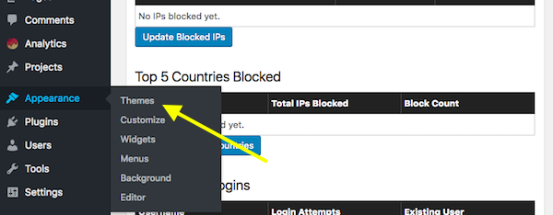
At the top of the page, click on “Add New”. This will take you to the WordPress repository from within WordPress. Use this option so you don’t have to do any manual installation.
Once you’re in the repository, do a search for the WordPress theme you want to use. Hover over it, and click the “Install” button.
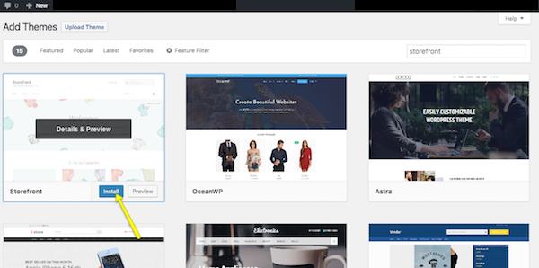
When it’s done installing, you then have to activate it in order to publish it to your WordPress site. Click on “Activate” (in the same spot where the “Install” button was) and wait for it to take you back into the main WordPress dashboard.
Premium WordPress Themes
If you’ve decided to purchase a premium WordPress theme, the process will differ as third-party theme developers and marketplaces don’t sync directly to WordPress. Here is what you need to do:
Go to your WordPress theme’s page and purchase the file. Once you’ve done this, you’ll be taken to a screen where you can download the theme file. It will look something like this:
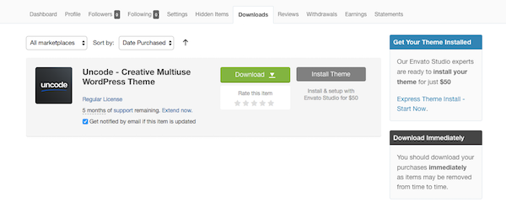
If there is an option for it, download the “Installable WordPress Files Only”. This will give you a zipped folder you can then upload directly into WordPress.
To do this, go back into WordPress, find the Appearance tab, and go to “Themes”. Click on “Add New” at the top. Only, this time, you’ll select the “Upload Theme” option.
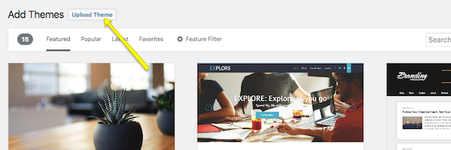
Select the zip file from your computer and click Install Now. With your new theme uploaded into WordPress, you can now activate and publish it to the site.

Step 6: Configure Your WordPress Theme
Upon activation, you’ll want to spend some time configuring your theme. You can do this under the Appearance tab and then click “Customize”.
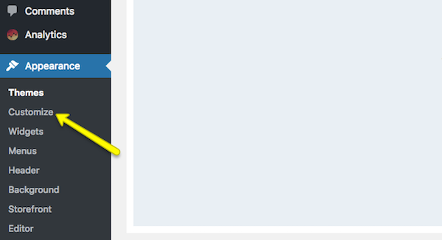
Ultimately, it’s up to you to decide how much or little of your theme you want to customize. However, you should at least take some time now to go through each of the modules and acquaint yourself with what you have the power to change.
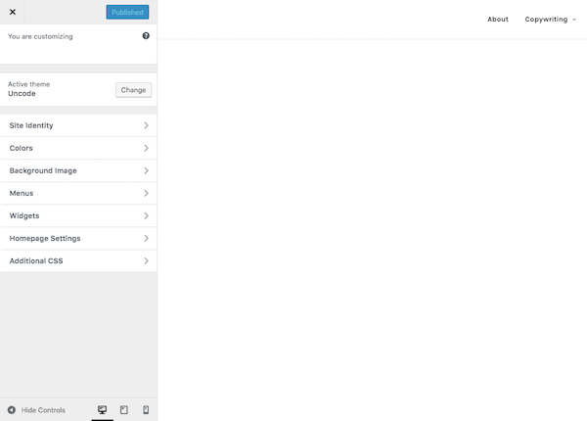
Site Identity is an important one to fill in, so make sure you look at that first.
Colors allows to update your site to your brand’s color palette (if you have one).
Widgets allows you to add content to your footer.
And Menus refers to your site’s navigation–something I’m going to cover in Step 8 so there’s nothing to do here just yet.

Step 7: Publish Your First Pages
There are two types of “pages” you can create for your website:
1. Page
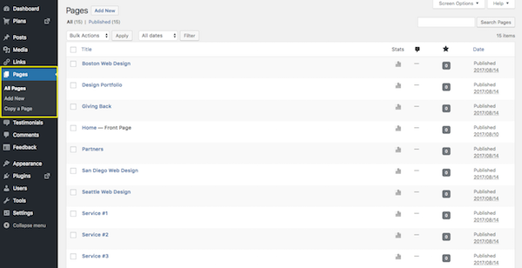
These are traditional web pages that exist within the main navigation of a site. The About page, Contact page, and individual services pages all are made using the Page feature in WordPress.
2. Post
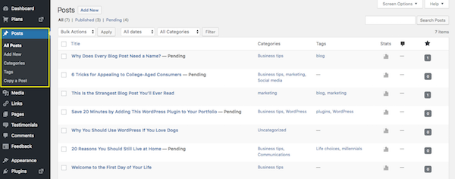
These are blog post “pages” that will only exist within the blog on your website, unless you designate the home page to serve as the blog feed (I’ll talk about that in Step 9).
Now, the great thing about WordPress is that the interface is consistent regardless of whether you’re creating a page or a post. There are different settings you need to apply to each, but the main area in which you work remains the same, which makes it a workspace that’s easy to get used to.
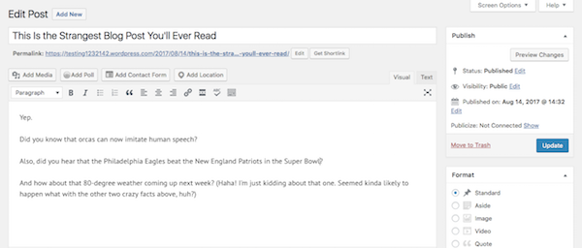
Of course, if you work in a theme that uses a page builder or a visual builder tool to create content, this is going to look a little different.
A page builder tool allows you to create “blocks” of content for your site within WordPress. Once the blocks are in place, you can then populate them with corresponding content.
A visual builder tool works similarly in that it allows you to create blocks of content for your site–however, it does it on the front end of the actual site so you can see your changes in real time. Upfront is an example of this.
Regardless of which content creation tool your WordPress theme uses, it’s time to create content for your site.
If you’re running a blog, simply get started writing your first Posts. Once you hit the Publish button, your blogs will go live on the designated Blog page.
For a traditional website, you’ll probably want to build out the following pages:
- Homepage
- About page
- Services or products page(s)
- Contact page
As your website grows, you can create other pages. For now, those will suffice. Get some content on them, publish the pages, and then let’s work on getting them onto your website.

Step 8: Create a Menu
Whereas when you hit the “Publish” button on a Post and it goes straight onto your blog, a Page needs to be added to your site’s navigation (or menu) if you want it to show up.
So, the first thing to do is to create those pages for your site (which you did in Step 7).
Next, you’ll want to go to the Appearance tab and select “Menus”. This is where you will build and manage your site’s navigation.
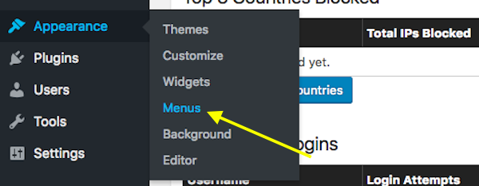
There is kind of a lot going on here, so let’s take this one step at a time.
First, let’s look at the menu selection dropdown.
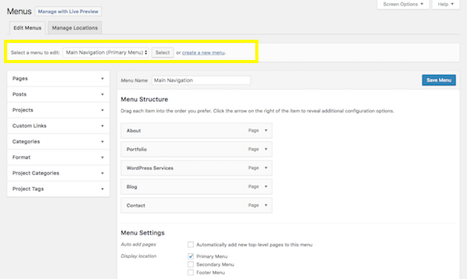
Unless you have a need for a mega menu or multiple menu options on your site, you likely won’t even have a choice here. However, if your theme automatically creates secondary or footer menus for you, be sure to select the one you actually want to create/edit here.
Next, let’s look at the sidebar options.
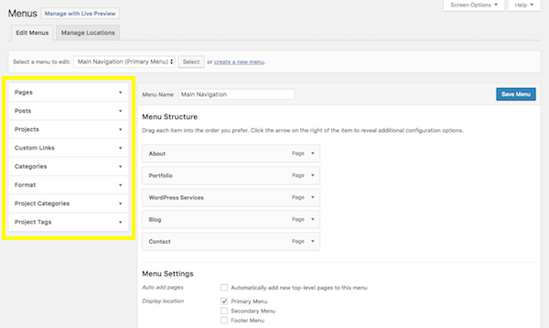
When you expand these tabs, you’ll be presented with pages, posts, and other types of content that already exist on your site (which is why you need to at least start on Step 7 before doing this step). For the most part, you’ll be working within the Pages tab to create your menus. However, if you do have custom links or other content types you want to add to the navigation, know that this tool allows you to make that happen.
Now, it’s time to create your menu.
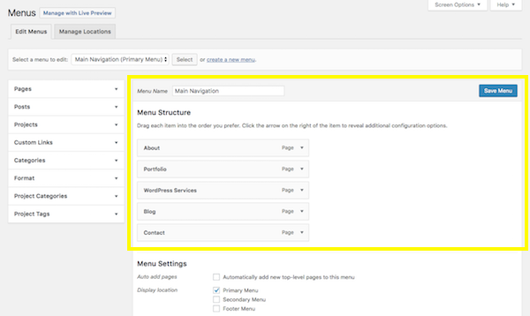
In order to get pages to show up under the Menu Structure section, click the checkbox next to the page (or pages) you want to add to the sidebar. Then click on the “Add to Menu” button. You’ll see those pages then show up under Menu Structure.
Within this interface, you can now drag-and-drop your pages and design your menu to appear however you’d like it to. In addition to placing pages in a custom order, you can also create a hierarchy. So, let’s say you wanted “Portfolio” to appear only when someone hovers over the About tab, simply drag that page inward so that it becomes a subitem:
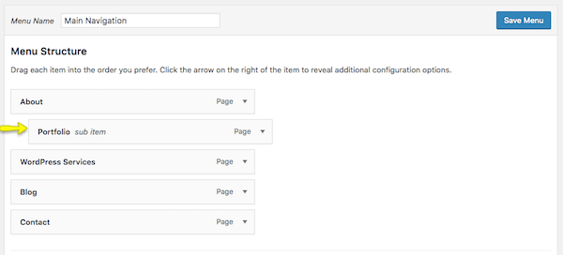
You can also change the page labels that appear in the navigation. For instance, let’s say you called the page “Portfolio” in WordPress so your employees would know where to put examples of your work. However, on the customer-facing side of the website, you think it would be clearer if you called the page “Sample Work”. You can rename it here.
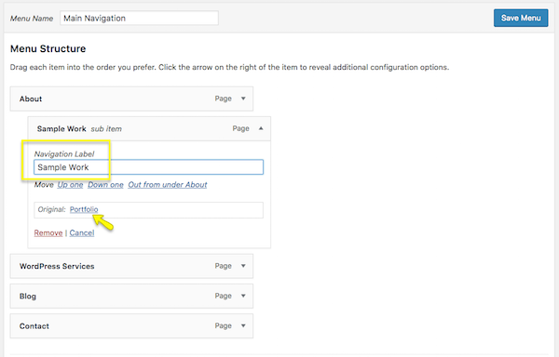
One other thing to point out here is the Menu Settings box at the bottom.
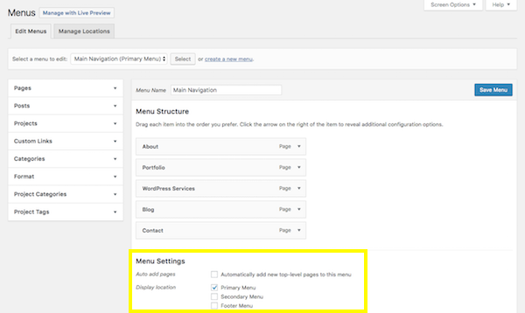
If you know that you’ll be adding new pages regularly to your website and don’t want to have to repeat this process every time, you can click on the “Automatically add new top-level pages to this menu” option to streamline your process.
When you’re done setting up your menu, save your changes.

Step 9: Configure Your WordPress Settings
I typically advise new WordPress users to leave the settings setup until this stage of the process. Many of the settings offered by WordPress control things related to your pages and posts, and that’s not necessarily something you’d understand until you’ve actually created them for your site.
So, now that you’ve done that, it’s time to go through your settings one-by-one and make sure your WordPress site is configured to work exactly as you want it to.
General
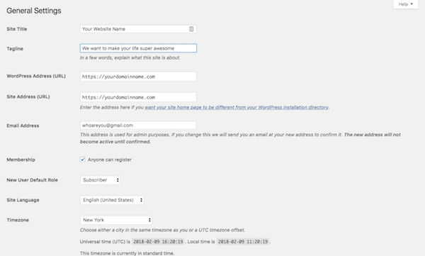
- Site Title: This is what will appear in someone’s browser tab when they arrive at your site.
- Tagline: This can be changed when you create content for your home page, so this isn’t a required field.
- WordPress Address: This is the URL of your main site.
- Site Address: For most of you, this will match the WordPress Address. However, if you are setting up something like Multisite that requires each site have its own sub-domain, you’ll specify that here.
- Email Address: This is for the main admin of your site, so they can receive all related notifications regarding it.
- Membership: If you want people to subscribe to your site for updates, click this box.
- New User Default Role: Keep this to Subscriber or Customer so that they can’t gain access to the backend of your site.
The rest of the information pertains to date and time configurations.
Writing
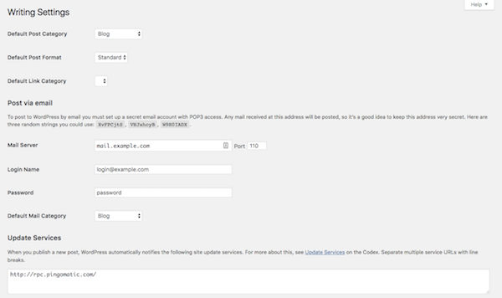
- Default Post Category: If you’re including a blog on your site, you should eventually come in here and remove the “Uncategorized” category. You’ll want each new post to be assigned a category and removing the default setting will make it easier on yourself in the future.
- Default Post Format: For the most part, “Standard” should suffice unless you’re using your blog to share video, audio, or image galleries.
- Post via email: If you want to be able to write WordPress posts and email them to your site (which I wouldn’t advise), you can enable this setting here.
- Update Services: Leave this field be unless you have a private blog and don’t want people to know when you have new content available.
Reading
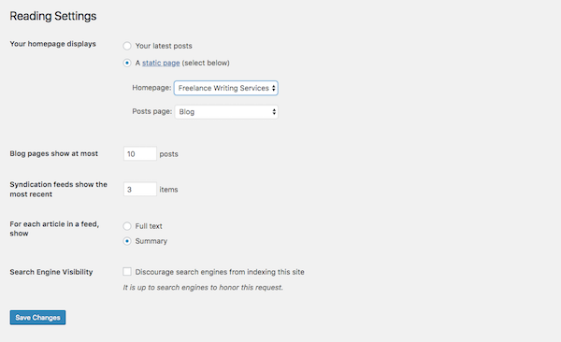
- Your homepage displays: You have two choices when setting up a site in WordPress. You can let your homepage serve as the main blog roll, so that visitors first encounter “Your latest posts”. Or you can create a full-blown website and let “A static page” you created serve as the home page.
- A static page: If you select this second option, you’ll need to designate a page to be your homepage and a page to automatically display your posts on.
- Blog pages show at most: If you show a summary of your blog posts (see option below), you can display up to 10 posts per page. If you show the full text, try to limit this to 3 posts.
- Syndication feeds show the most recent: When your blog shows up in someone’s RSS (syndication) feed, this setting enables you to choose how many recent posts they’ll see initially.
- For each article in a feed, show: This is up to you to decide, though I think a summary is probably best for improving the overall look on a main blog page’s feed. It also gives visitors a reason to click through and visit another page (which is good for SEO).
- Search engine visibility: Unless your website is private, do not check this box.
Discussion
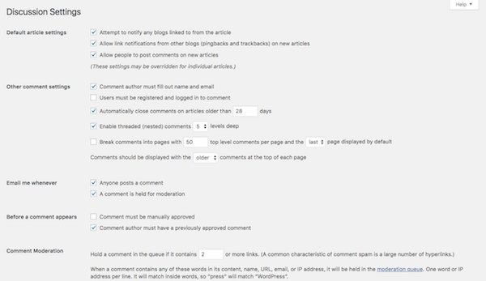
- Default article settings: The first setting refers to backlink notifications. The second setting refers to pingbacks and trackbacks. The third has to do with allowing comments on your blog.
- Other comment settings: If you do want visitors to leave comments, you can set requirements on who they are as well as how comments appear.
- Email me whenever: Staying engaged with people who take the time to comment on your content is a good thing. Check these so you can more easily stay on top of that.
- Before a comment appears: If you’re worried about spam or abusive comments coming through, update these settings.
- Comment Moderation/Blacklist: You can decide more specifically who is allowed to leave a comment (so long as it’s moderated) and who isn’t.
- Avatars: If you’re not running a membership site that allows users to create a full custom profile, be sure to update these settings to give your comments section a little personality.
Media
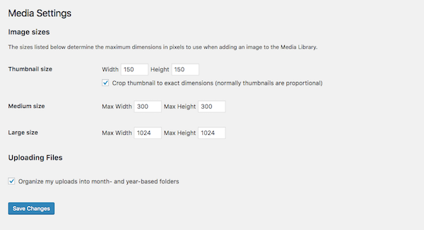
If you’ve designed a custom WordPress site, you may have a need for custom media file sizes. In using this setting, you can streamline the media upload and sizing process. That way, visual content automatically goes into your pages at the right size and you don’t have to worry about making adjustments of it in your design software or compromising visibility of the image once it’s in WordPress.

Step 10: Install Essential WordPress Plugins
Installing WordPress plugins is the final step in the WordPress setup process.
In terms of what a WordPress plugin is, it’s a piece of software that hooks into WordPress. As for what it does? Well, plugins can do a lot of different things. They can help you:
- Integrate a social media feed into your site.
- Resize and compress images.
- Block spammers and hackers.
- Create a forum.
- Add a payment gateway.
- Translate your site.
- And much, much more.
So, how do you choose which ones you need?
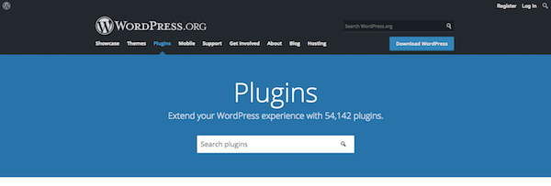
While it’s tempting to look through the WordPress repository that currently houses over 50,000 free plugins and install all of the ones that seem really cool or worthwhile, be careful. WordPress plugins are like any other kind of file or software you layer on top of your site. With more weight, comes slower loading times–and that’s not something you want for your user experience.
That’s why you need to choose your plugins wisely. To start, let’s look at the absolute plugin essentials every WordPress site needs:
- Google Analytics plugins: Tracking visitor activity on your WordPress site is essential. However, getting the Google Analytics tracking pixel on your site isn’t always that straight-forward. These plugins will take care of it.
- SEO plugins: These plugins are great as they provide guidance on what you need to do on each page or post to optimize it for search.
- Caching (speed) plugins: People don’t have much patience anymore and you don’t want your site to test that, so you’ll need one of these plugins.
- Image optimization plugins: Every website uses images, whether they’re your own high-resolution photography or really cool stock photos and illustrations you found on the web. If you want to keep them looking sharp and loading fast, you need one of these.
- Security plugins: With WordPress being so popular around the world, it’s often a common target for hackers. A security plugin will help you create a stronger defense against them.
- Contact form plugins: If you’re publishing a site to the web, then you most definitely want people to not only visit it, but to engage with you through it. A contact form is an essential piece required for that interaction to take place.
As for getting these plugins onto your site, well, that’s the easy part. The process is almost identical to WordPress theme installation.
Inside WordPress, go to the Plugins tab on the left and select Add New. This will take you to the WordPress repository without forcing you to leave your site.
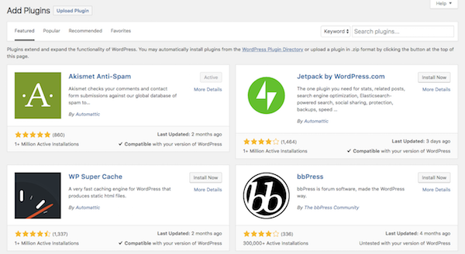
Once inside, you can do a search on the right for the plugin you want to install. You’ll have to do this process one-by-one for each of your plugins.
Next to the plugin name, you’ll see an “Install Now” button. Click it.
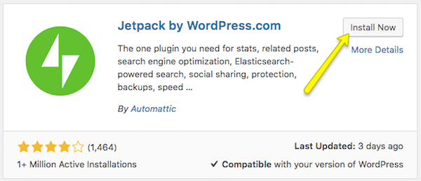
Once installation is complete, you’ll see a page like this. Click on Activate Plugin.
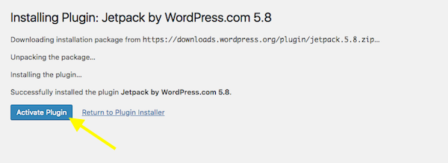
Some plugins will require some configuration before you can use them and will automatically redirect you to their settings page to do so. Other plugins are ready to go out of the box. Regardless of which kind of plugin you’ve just installed, you’ll be able to find it here under “Installed Plugins”:
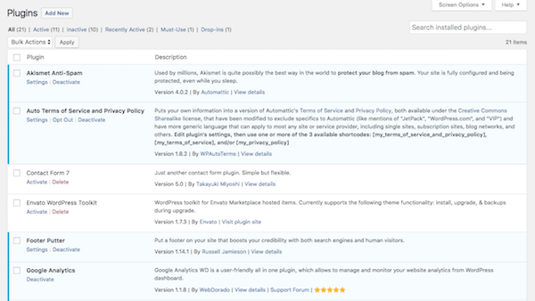
Plugins in blue are currently activated. Plugins in white are not inactive. To activate a plugin, click the “Activate” button below it. To “Deactivate” or “Delete”, do the same. And, for plugins that have settings you can configure, you can click that button if it’s available.
It’s also important to note that some of your plugins will generate their own new tab on the sidebar. Take WP Smush, for instance. If you’ve chosen to use this image optimization plugin, you’ll now find that it’s installed a new option on your sidebar:
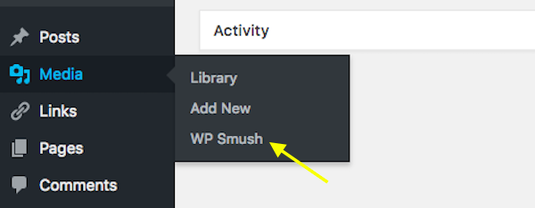
So, be sure to look out for those new tabs after activation as they hold valuable settings and features you’ll want to start accessing right away.

Wrapping Up
WordPress is the undisputed champ of content management systems, which is why there’s never been a better time to learn how to use it. In just 10 steps (and some careful research and planning), you can get your first WordPress website up and running! Good luck!

https://premium.wpmudev.org/blog/the-ultimate-wordpress-backend-tutorial-a-guide-to-customization/:
The Ultimate WordPress Backend Tutorial: A Guide to Customization
here’s a lot that goes into developing WordPress websites from the ground up, which is why I hope you’ve found the WordPress startup guide helpful. Having one cohesive guide that walks you through the process step-by-step can be an invaluable tool when you’re first starting work as a WordPress developer.
Once you’ve mastered the WordPress website setup process, be sure to tackle the SEO tutorial next. This will teach you all the ways in which you should optimize a website for search, whether they be more obvious tasks like keyword optimization or less obvious ones like page speed enhancements.
Then, when that’s under your belt and you know how to make a truly fine-tuned WordPress site, it’s time to start looking at ways in which you can use your clients’ WordPress installations to support your business’s goals. Not sure what I’m referring to? Then this WordPress backend tutorial is for you.
In this tutorial, I’m going to talk about how you can turn the backend of WordPress into a lean, mean content management machine for your clients… as well as a promotional tool for your WordPress business. Trust me, if you’re serious about building and eventually expanding your WordPress development services, then you definitely need to learn how to do this.

The Ultimate WordPress Backend Customization Tutorial
When all is said and done and you’ve completed development on a new WordPress website, you’re left with a dashboard that looks something like this:
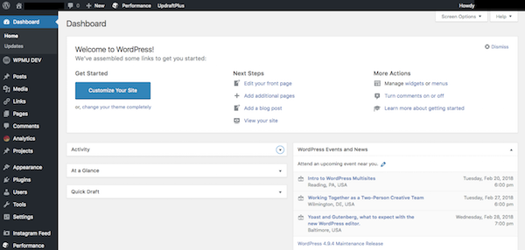
The WordPress interface is inherently well-designed and intuitive, and there’s absolutely nothing wrong with leaving it in its natural state. However, once you start adding premium themes and installing a bunch of plugins to optimize your site’s performance and security, the menus and dashboard can get a little cramped. If you want to deliver a truly premium service to your clients, you should think about customizing the WordPress backend.
Why would you want to do this? Well, there are a number of reasons actually.
- For one, a cleaned-up backend can keep clients from unintentionally doing harm to their websites.
- By branding the backend with the client’s logo and color scheme, and creating a more refined space for them to work in, you’ll turn WordPress into a more welcoming environment. The less threatening WordPress is, the more your clients will use it to keep their sites updated!
- You can also use this opportunity to provide ongoing support to clients even if you’re not actively working on their site. Your clients will appreciate you having the foresight to leave behind support material, helpful tips, as well as your contact information.
Sounds pretty great, right? Let’s jump right in and review how you can make this happen. All it should take is a handful of plugins and maybe an hour of customizations to get your WordPress backend in tip-top shape.

Contents
The Ultimate WordPress Backend Customization Tutorial 27
1. Install a Branding Plugin 30
2. Customize the Login Page 31
3. Adjust Login Security Settings 33
4. Change the Toolbar Message 34
5. Revamp the Admin Toolbar Menu 34
6. Revamp the Admin Menu Sidebar 35
7. Hide Plugins 37
8. Customize the Colors of the Dashboard 37
9. Remove Dashboard Widgets 38
10. Add Dashboard Widgets 39
11. Create Help Resources 40
12. Add Tips Around WordPress 41
13. Restrict Access Based on Role 42
Wrapping Up 43

1. Install a Branding Plugin
Most of the customizations we’re about to cover can be executed by using a WordPress plugin. So, if you’re nervous about having to code these changes into the backend of the site, don’t worry.
There are actually quite a lot of backend customization plugins available–and I’ll include some suggestions as we go along here. But, to start, I would suggest you install WPMU DEV’s Ultimate Branding plugin.

This is going to give you the biggest bang for your buck in terms of how much customization you can do with a single plugin.
Once the plugin is installed, locate the Branding tab on the WordPress sidebar. You can enable the various modules for customization here.
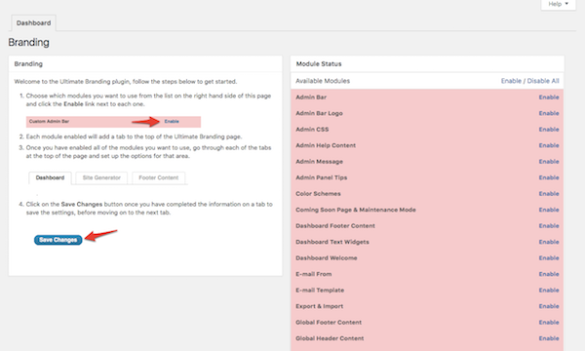
Click on the Enable All button in the top-right corner. The following steps will cover how to use these to effectively customize the WordPress backend.

2. Customize the Login Page
Let’s start with the front door of your website: the login screen.
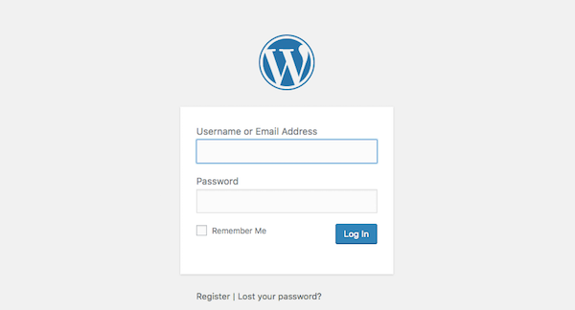
This is the default login screen. Again, there’s nothing wrong with the login page, but there’s room for improvement here.
Using the Login screen setting, let’s configure this so you can display your client’s logo and colors instead.
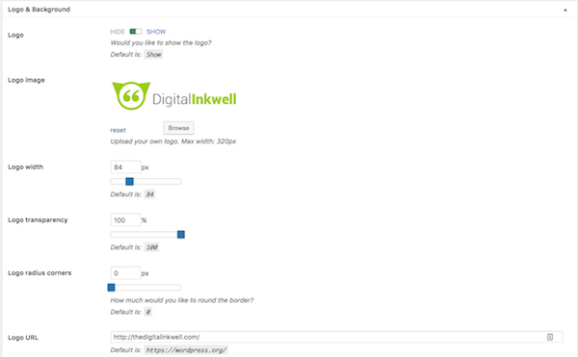
In this Logo & Background section, do the following:
- Replace the WordPress logo with that of your client.
- Remove the logo link and alt text or replace it with that of your client’s website.
- Change the background of the login page. You can assign it a solid color (from your client’s color palette) or place a branded image of theirs as the background photo.
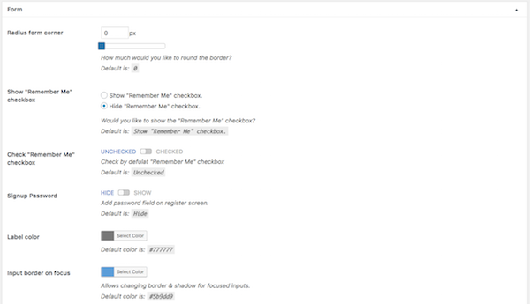
In the Form section, the only things I might suggest you update are the colors to match your client’s branding. Otherwise, the default configuration and style of the WordPress login form is pretty solid. It’s simple, easy to use, and doesn’t ask for too little or too much.
For the Form Labels, Error Messages, Before Form Links, and Form Canvas & Position sections, you might not have much to update here aside from colors. Of course, with any of these, you’re free to go as crazy as you’d like with customizations. You know your clients better than anyone else, and so you’ll understand which customizations will lead to the best user experience for them.
The last piece I want to direct your attention to here is the Redirects section:
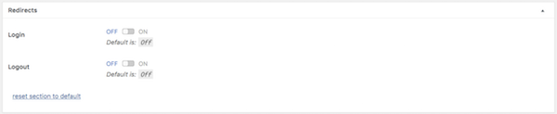
This may be particularly helpful if you want all users to immediately be directed to a specific page (either inside or outside WordPress) when they log in or out. You’ll likely want to use this if you run a membership site or a Multisite network.

3. Adjust Login Security Settings
For this next customization, I’m going to suggest you use the Defender plugin.
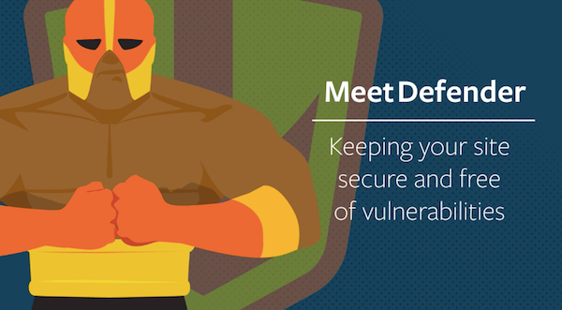
In addition to its awesome WordPress security capabilities, it allows you to create a two-factor authentication for the login page.
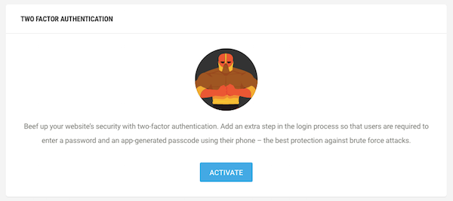
Now, I’m not saying that you can’t trust your clients to do a good job creating strong passwords… it’s just that you have to assume the best but prepare for the worst here. Two-factor authentication ensures that, even if they do a terrible job generating a password for WordPress, they’ll be forced to authenticate their identity on another device.

4. Change the Toolbar Message
I think it’s fair to say that no one ever really liked the Hello Dolly WordPress plugin, which is why it’s always the first one that gets the heave-ho when you set up a new WordPress site. Once it’s gone, you’ll be left with a “Howdy, [username]”, and that’s totally fine by me. At least now your clients will have a somewhat personalized greeting at the top of the dashboard.

5. Revamp the Admin Toolbar Menu
We’re now ready to work our customization magic in the admin toolbar:
This doesn’t look too bad, right? Right. But that doesn’t mean there aren’t a few changes we can make to improve the menu options available. Let’s take a look at what the Ultimate Branding plugin can do.
Open the tab called Admin Bar and scroll down to the Hide Menu Items section.
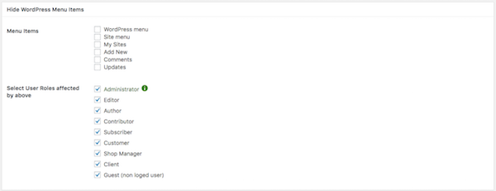
In this section, you can remove any of the menu items in that top bar. So, if you don’t think it’s necessary for your clients to see the WordPress drop-down that out to various WordPress About and Help pages, click on the checkbox next to it. If you want to disable clients from visiting their site from the top menu (because it might be too confusing), check that one too. Just think about this from their perspective and leave only what would be the most beneficial for them to have here.
Next, go to the Advanced Settings section. Click on the button that says “Reorder Menus”.
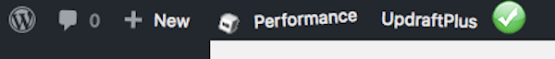
Notice how the top toolbar menu now starts doing a little jig. This is to let you know you can drag-and-drop these menu items around into a different order if you think it’ll improve the user experience. When you’re done setting the order, make sure to hit the Save button at the bottom.
Note that if you choose to leave the WordPress menu in the toolbar, you can swap out the logo for the client’s (same as you did on the login page).
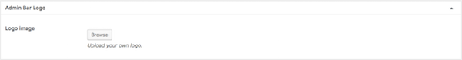
For consistency’s sake, I’d suggest you do that now.

6. Revamp the Admin Menu Sidebar
Once you have the admin toolbar at the top of the dashboard cleaned up and customized, it’s time to turn your attention to the sidebar.
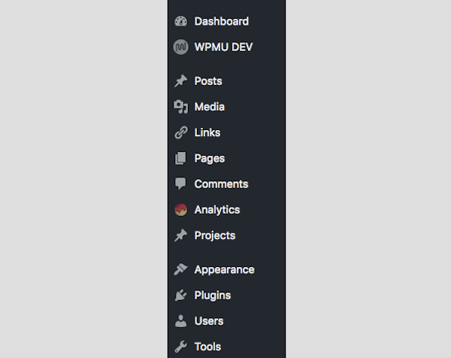
If you want to have the same sort of control over the sidebar elements as you did the toolbar, I’d recommend you install the Admin Menu Editor plugin.
Once installed, here is what your menu editor tool will look like:
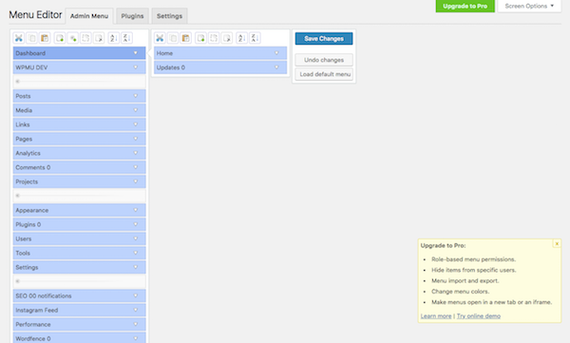
From the Admin Menu tab, you can:
- Change the name of the menu items as well as where they get directed to.
- Delete menu tabs altogether.
- Add new menu tabs (which would be helpful if you want to add custom support or help resources to the menu).
- Drag-and-drop menu items into a new order.
- Add separators to better organize your menu.
- Move sub-menu items out into the main menu and vice versa (e.g. if you wanted the Customize tab under Appearance to be on the main sidebar).
This gives you total control over how the menu appears, using the phrasing that makes the most sense for your clients, and in the order that’s the most logical.

7. Hide Plugins
The Admin Menu Editor plugin is also helpful if you want to hide certain plugins from your users.
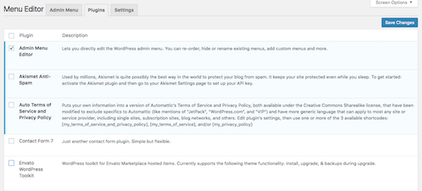
That doesn’t mean you’re deactivating the plugins or that you’ll lose access to them. Instead, you’ll simply be hiding them from view within the Plugins tab so that no one but those granted explicit access to them can update the settings, deactivate, or activate them.

8. Customize the Colors of the Dashboard
Ideally, the color scheme of the WordPress dashboard will match whatever skin you applied to the login screen. However, if you have a reason to give something else a try, know that you have a couple options to play with here.
If you’re using the Ultimate Branding plugin, go to the Color Schemes tab.
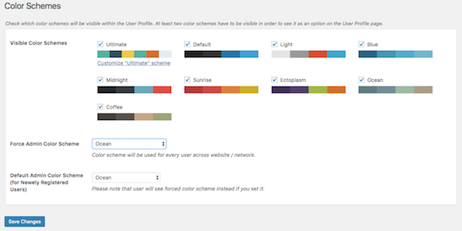
In this tab, you can control two things:
- You can enable which WordPress color schemes you want to make available to users.
- You can choose an alternate color scheme for users to see upon logging in.
Your second option is to install an admin theme plugin. Some of these plugins work similarly to Ultimate Branding in that you can customize things like the login or admin toolbar, but there are also some that simply provide a better-looking color scheme.

9. Remove Dashboard Widgets
The WordPress dashboard automatically comes loaded with the following widgets:
- At a Glance
- Activity
- Quick Draft
- WordPress Events and News
If you want to deactivate any of these and prevent your clients from seeing them, click on the ones you want to be removed under the Widgets tab in Ultimate Branding.
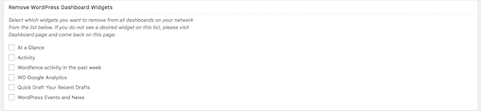
You can also disable any widgets that auto-generated when you installed a new plugin. That said, it really is ideal to have a Google Analytics widget installed on your dashboard, so don’t remove that one unless you have good reason to.
Within this same section, you can also change the default WordPress welcome message that appears on the dashboard.
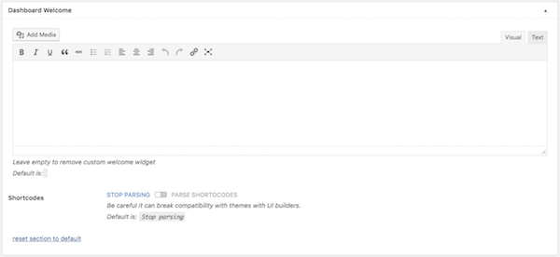
Simply type something into this text box and save your changes to load up the new welcome message.

10. Add Dashboard Widgets
For those of you feeling adventurous and wanting to give your clients a truly impressive and well-supported experience in WordPress, I’d suggest you utilize the Dashboard Text Widgets tab.
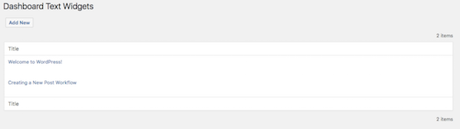
In this tab, you can create text-based widgets for your dashboard. So, if you have simple directions you want clients to follow or want to provide them with a reminder on how to get in touch when they need help, you can create those messages here.
Once saved, they’ll show up in the dashboard just like all the others:
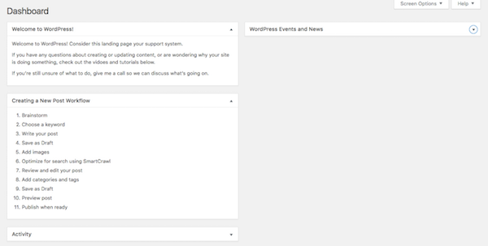
Feel free to get creative with whatever you place in this section. Just remember that the widgets should be relevant and helpful. If they only distract or annoy your clients, they’ll end up hiding your widgets just like the default ones from WordPress that tend to get in the way.

11. Create Help Resources
In the Help Content tab of Ultimate Branding, you can create any number of messages for your clients.
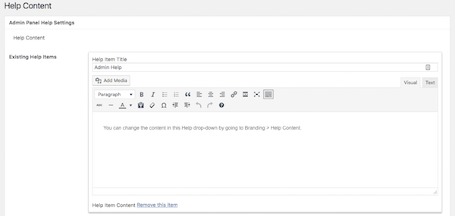
You can include helpful reminders: “Always save a post as Draft before Publishing!”
You can share tips on how to make the most out of their new WordPress website: “Reminder: set Smush Pro to automatically compress images.”
You can include a list of resources to help your clients out if they get stuck or need further assistance (including your own contact information).
Anything you might find helpful, you can include up here. Just be sure that they’re aware of this “Help” tab that now appears in the top-right corner of the WordPress dashboard.
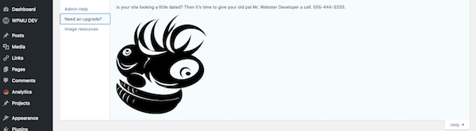

12. Add Tips Around WordPress
In addition to being able to communicate with your clients in the new Help tab as well as within custom dashboard widgets, you can also create tips that reach them at various locations around WordPress.
You can create these tips under the Tips tab.
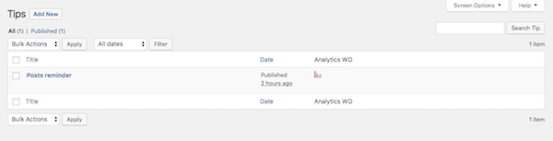
Looks familiar, right? The creation of these tips is actually no different than creating a new post or page in WordPress.
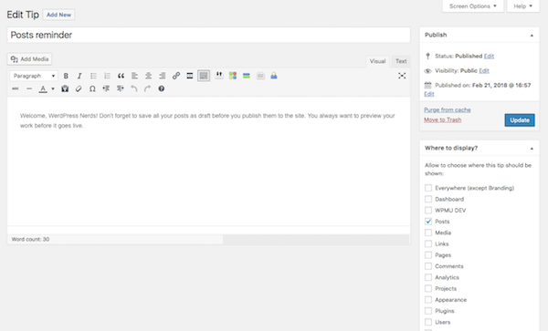
The only difference is that you now get to choose where this tip is displayed. If it’s a tip specific related to something like writing blog posts, for instance, then you could assign it to only display on the Posts page. Or if it’s a more generic tip (like “Always remember to save your work”), you can apply it across all of WordPress.

13. Restrict Access Based on Role
There’s one other plugin you should think about using in WordPress as you seek to customize the backend for your clients. This one is called User Role Editor and it will give you deeper control over defining user roles on the site and what they’re able to access within the WordPress admin.
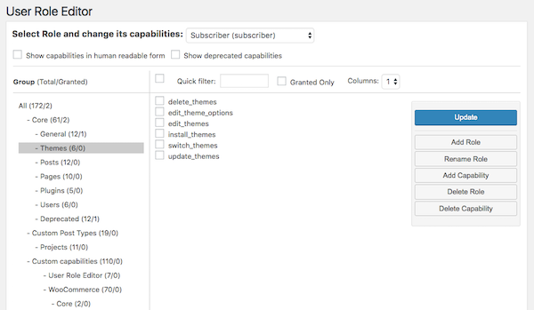
To control more of what your users can do in WordPress, navigate to the Users tab and go to the new User Role Editor tool. Within this section, you’ll see that you can fully customize what each role is capable of doing.
Now, when it comes to keeping clients in line, you’ll probably want to focus more on Core capabilities. This is where you can refine what exactly they’re able to do to the WordPress themes and plugins within the site, whether that be adding new ones, deactivating ones you put on there, and so on. Also be sure that the “General” privileges for their given roles are exactly what you want them to be (which really should only be “read” rights).
At the bottom of this tool, you can also hide the top admin bar altogether if you’re finding it’s too confusing to include that along with the sidebar menu.

Wrapping Up
You might not think there’s much that can be done to customize the actual WordPress content management system, but, as you can see from this WordPress backend tutorial, there are quite a few opportunities here to leave a lasting impression with your clients. Be sure to set yourself up with the right WordPress plugins to start and save yourself the hassle of trying to code these changes in on your own.

